Nonagonal Trapezohedron

Definition
# Source: AI Source: Provided by: [Data Path: Persons Table -> ID Column: 1, Name_En Column: Motasem Essam] -> From: [ChatGPT] on [7/25/2026]
A Nonagonal Trapezohedron is a three-dimensional convex polyhedron consisting of 18 congruent kite-shaped faces arranged symmetrically around a central axis.
It has two opposite apexes connected by a ring of nine vertices. The faces are kites rather than trapezoids, despite the name trapezohedron.
It is also known as a 9-gonal trapezohedron or a deltoidal nonagonal icositetrahedron.
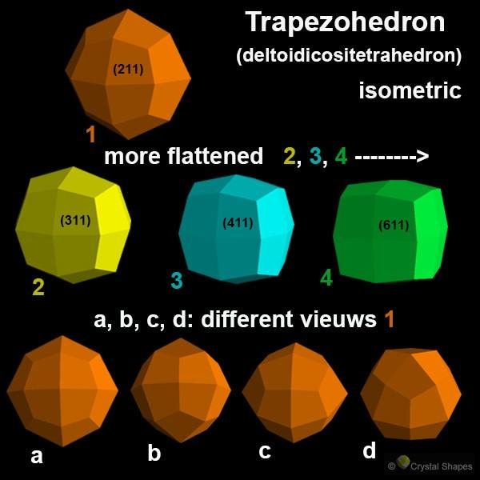
<caption>Nonagonal trapezohedron – a nine-sided trapezohedron with 18 kite-shaped faces. </caption>

Simple Definition
# Source: AI Source: Provided by: [Data Path: Persons Table -> ID Column: 1, Name_En Column: Motasem Essam] -> From: [ChatGPT] on [7/25/2026]
A Nonagonal Trapezohedron is a polyhedron made of 18 congruent kite-shaped faces arranged around a central axis, with two opposite apexes and two staggered rings of nine vertices.

Geometric Structure
# Source: AI Source: Provided by: [Data Path: Persons Table -> ID Column: 1, Name_En Column: Motasem Essam] -> From: [ChatGPT] on [7/25/2026]
The nonagonal trapezohedron has three main structural components:
- Upper apex: The top vertex where nine kite-shaped faces meet.
- Lower apex: The bottom vertex where the other nine kite-shaped faces meet.
- Two staggered vertex rings: Two arrangements of nine vertices each, positioned around the central axis and rotated relative to one another.
The staggered arrangement creates the characteristic twisted appearance of the solid.
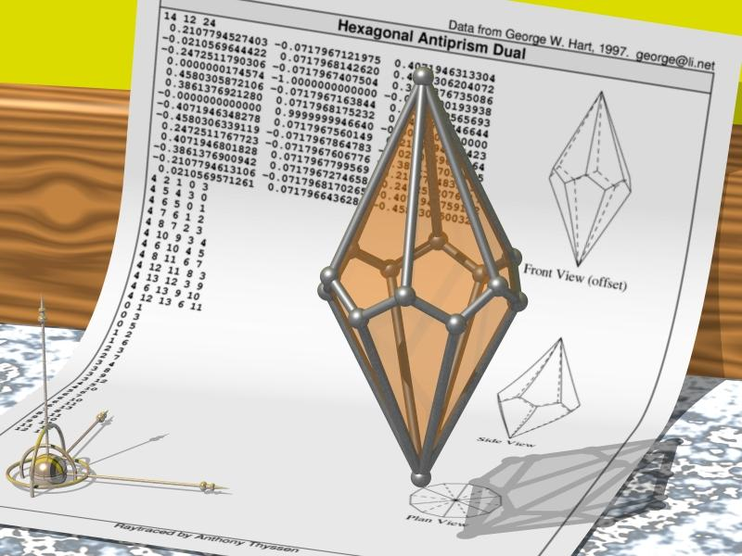

Face Structure
# Source: AI Source: Provided by: [Data Path: Persons Table -> ID Column: 1, Name_En Column: Motasem Essam] -> From: [ChatGPT] on [7/25/2026]
A nonagonal trapezohedron has 18 congruent kite-shaped faces.
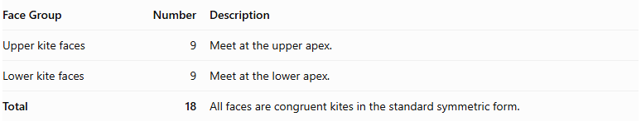
Face Group | Number | Description
Upper kite faces | 9 | Meet at the upper apex.
Lower kite faces | 9 | Meet at the lower apex.
Total | 18 | All faces are congruent kites in the standard symmetric form.
A kite is a quadrilateral with two pairs of adjacent equal sides. The faces are not ordinary trapezoids, despite the solid's name.
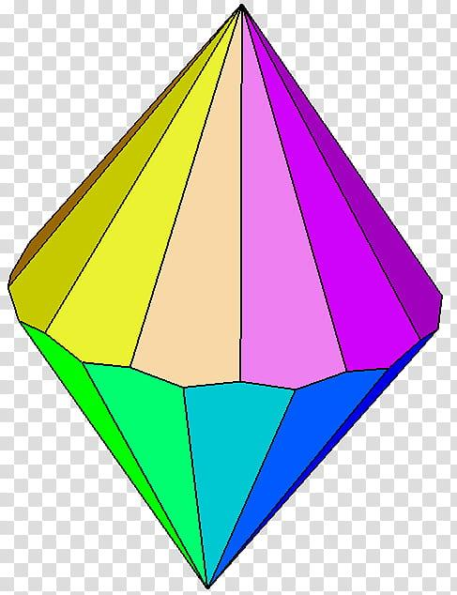

Edge Structure
# Source: AI Source: Provided by: [Data Path: Persons Table -> ID Column: 1, Name_En Column: Motasem Essam] -> From: [ChatGPT] on [7/25/2026]
A nonagonal trapezohedron has 36 edges.
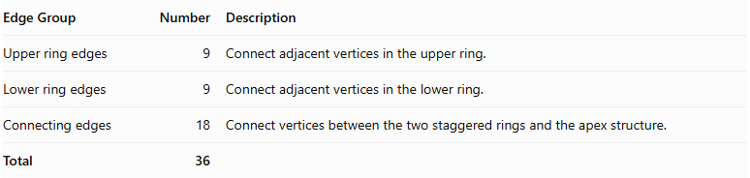
Edge Group | Number | Description
Upper ring edges | 9 | Connect adjacent vertices in the upper ring.
Lower ring edges | 9 | Connect adjacent vertices in the lower ring.
Connecting edges | 18 | Connect vertices between the two staggered rings and the apex structure.
Total | 36

Vertex Structure
# Source: AI Source: Provided by: [Data Path: Persons Table -> ID Column: 1, Name_En Column: Motasem Essam] -> From: [ChatGPT] on [7/25/2026]
A nonagonal trapezohedron has 20 vertices.
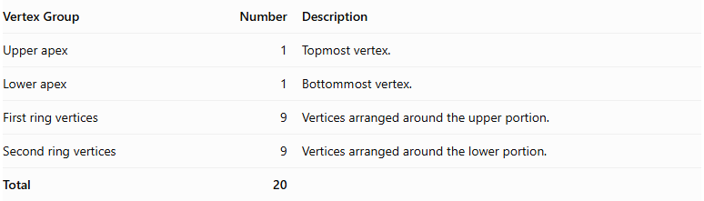
Vertex Group | Number | Description
Upper apex | 1 | Topmost vertex.
Lower apex | 1 | Bottommost vertex.
First ring vertices | 9 | Vertices arranged around the upper portion.
Second ring vertices | 9 | Vertices arranged around the lower portion.
Total | 20
At each apex, nine faces meet. At each of the other 18 vertices, three faces meet.

Mathematical Properties
# Source: AI Source: Provided by: [Data Path: Persons Table -> ID Column: 1, Name_En Column: Motasem Essam] -> From: [ChatGPT] on [7/25/2026]
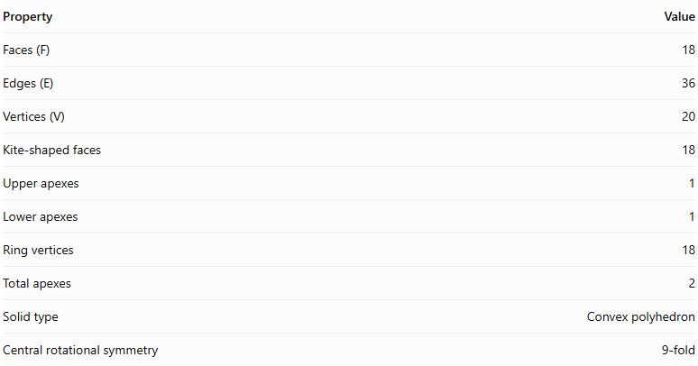
Property | Value
Faces (F) | 18
Edges (E) | 36
Vertices (V) | 20
Kite-shaped faces | 18
Upper apexes | 1
Lower apexes | 1
Ring vertices | 18
Total apexes | 2
Solid type | Convex polyhedron
Central rotational symmetry | 9-fold
It satisfies Euler's polyhedron formula:
$$V-E+F=2$$
Substituting:
$$20-36+18=2$$
Therefore, the nonagonal trapezohedron satisfies Euler's formula.

Face Incidence
# Source: AI Source: Provided by: [Data Path: Persons Table -> ID Column: 1, Name_En Column: Motasem Essam] -> From: [ChatGPT] on [7/25/2026]
In a standard nonagonal trapezohedron:
- Each upper apex is shared by 9 kite-shaped faces.
- Each lower apex is shared by 9 kite-shaped faces.
- Each of the 18 ring vertices is shared by 3 faces.
- Every edge is shared by exactly 2 faces.
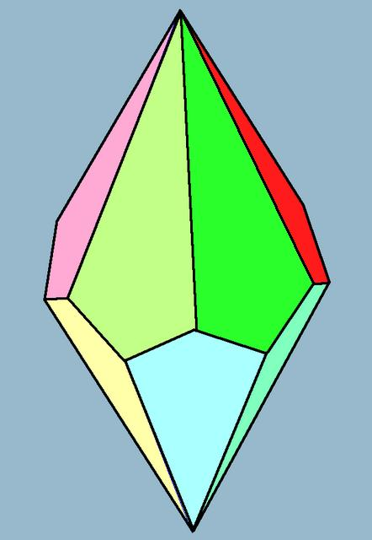

Surface Area and Volume

Surface Area
# Source: AI Source: Provided by: [Data Path: Persons Table -> ID Column: 1, Name_En Column: Motasem Essam] -> From: [ChatGPT] on [7/25/2026]
The total surface area is the sum of the areas of all 18 kite-shaped faces.
$$S=18A_{k}$$
Where $A_{k}$ is the area of one congruent kite-shaped face.
If the diagonals of each kite are $d_{1}$ and $d_{2}$, its area is:
$$A_{k}=\frac{1}{2}d_{1}d_{2}$$
Therefore:
$$\boxed{S=9d_{1}d_{2}}$$
This formula applies when all 18 faces are congruent kites.

Volume
# Source: AI Source: Provided by: [Data Path: Persons Table -> ID Column: 1, Name_En Column: Motasem Essam] -> From: [ChatGPT] on [7/25/2026]
The volume depends on the dimensions and spatial arrangement of the vertices.
For a convex nonagonal trapezohedron, the volume can be calculated by dividing the solid into smaller pyramids or tetrahedra and adding their volumes.
The general pyramid formula is:
$$V=\frac{1}{3}Bh$$
Therefore, for a decomposition into pyramids:
$$\boxed{V=\sum_{i}{\frac{1}{3}B_{i}h_{i}}}$$
Where:
- $B_{i}$ = base area of each component pyramid.
- $h_{i}$ = perpendicular height of that pyramid.
A numerical volume requires additional dimensions or vertex coordinates.

Symmetry
# Source: AI Source: Provided by: [Data Path: Persons Table -> ID Column: 1, Name_En Column: Motasem Essam] -> From: [ChatGPT] on [7/25/2026]
A regular nonagonal trapezohedron has the following symmetry properties:
- 9-fold rotational symmetry: Rotation by ${40}^{°}$ around its central axis leaves the solid unchanged.
- Vertical reflection planes: Nine reflection planes pass through the central axis.
- Horizontal reflection plane: In the symmetric form, the plane halfway between the two apexes reflects the upper half onto the lower half.
- Central inversion symmetry: The standard symmetric nonagonal trapezohedron does not have central inversion symmetry because its ninefold rotational arrangement has odd order.
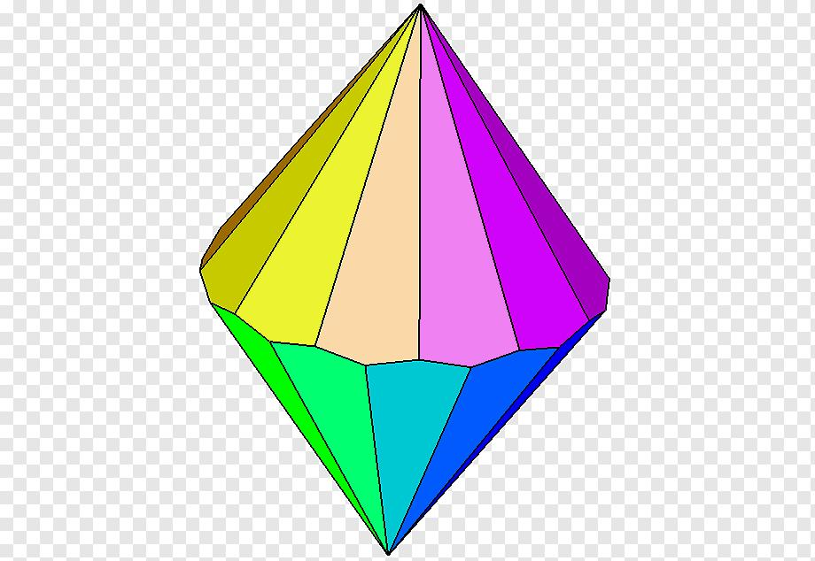

Relationship to Other Solids
# Source: AI Source: Provided by: [Data Path: Persons Table -> ID Column: 1, Name_En Column: Motasem Essam] -> From: [ChatGPT] on [7/25/2026]
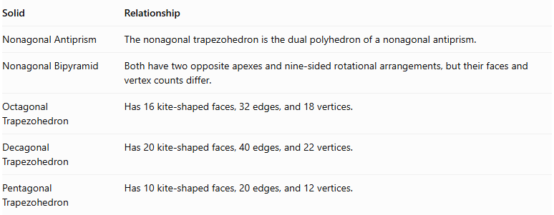
Solid | Relationship
Nonagonal Antiprism | The nonagonal trapezohedron is the dual polyhedron of a nonagonal antiprism.
Nonagonal Bipyramid | Both have two opposite apexes and nine-sided rotational arrangements, but their faces and vertex counts differ.
Octagonal Trapezohedron | Has 16 kite-shaped faces, 32 edges, and 18 vertices.
Decagonal Trapezohedron | Has 20 kite-shaped faces, 40 edges, and 22 vertices.
Pentagonal Trapezohedron | Has 10 kite-shaped faces, 20 edges, and 12 vertices.
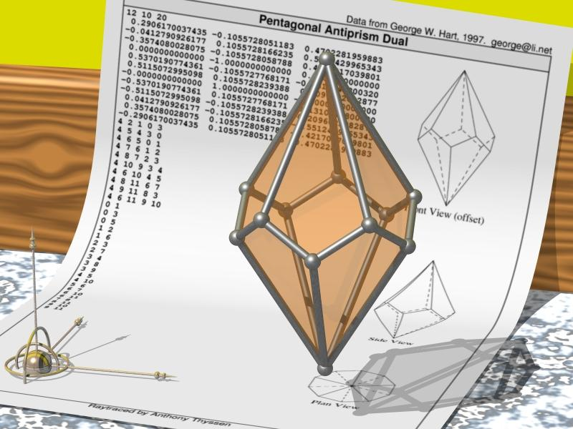
The dual relationship means that the vertices of the antiprism correspond to faces of the trapezohedron, and vice versa.

Worked Examples

Example 1: Calculate Faces, Edges, and Vertices
# Source: AI Source: Provided by: [Data Path: Persons Table -> ID Column: 1, Name_En Column: Motasem Essam] -> From: [ChatGPT] on [7/25/2026]
For an N-gonal trapezohedron:
$$F=2N$$
$$E=4N$$
$$V=2N+2$$
For N = 9:
- Faces = $2(9)=18$
- Edges = $4(9)=36$
- Vertices = $2(9)+2=20$

Example 2: Calculate Surface Area
# Source: AI Source: Provided by: [Data Path: Persons Table -> ID Column: 1, Name_En Column: Motasem Essam] -> From: [ChatGPT] on [7/25/2026]
Suppose each kite-shaped face has diagonals:
- $d_{1}=6\text{ cm}$
- $d_{2}=8\text{ cm}$
Area of one kite:
$$A_{k}=\frac{1}{2}(6)(8)$$
$$A_{k}=24{\text{ cm}}^{2}$$
Since the solid has 18 congruent faces:
$$S=18(24)$$
$$\boxed{S=432{\text{ cm}}^{2}}$$

Constructing Nonagonal Trapezohedron in Solid Geometry

Geometric Instruments Used
# Source: AI Source: Provided by: [Data Path: Persons Table -> ID Column: 1, Name_En Column: Motasem Essam] -> From: [ChatGPT] on [7/25/2026]
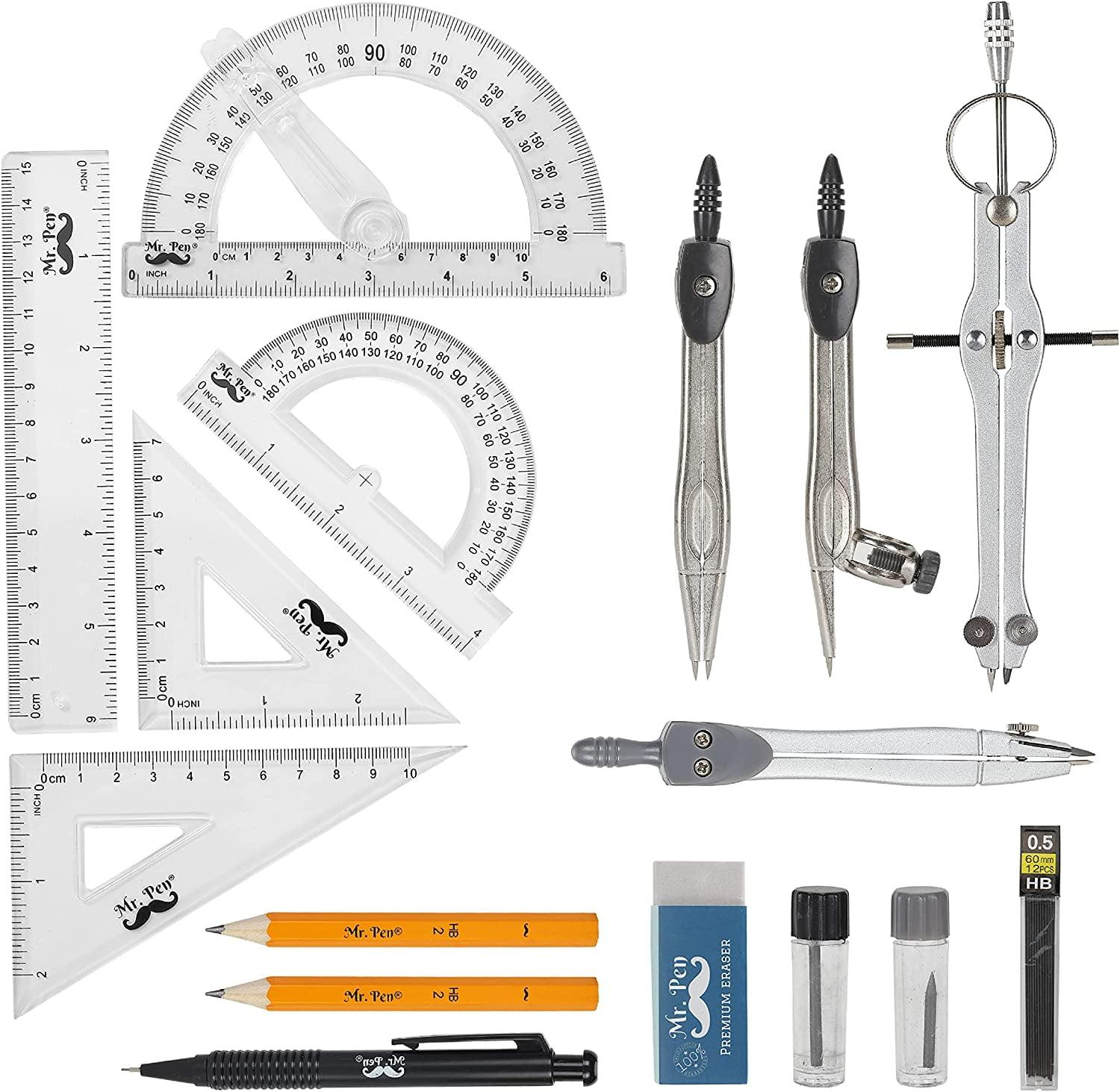
- Ruler: Drawing straight edges.
- Compass: Drawing circles and transferring distances.
- Protractor: Measuring angular divisions.
- Set square: Constructing perpendicular lines.
- Pencil: Drawing construction lines.
- Eraser: Removing unnecessary construction marks.

Instrument-Based Construction Procedures

A. Constructing the First Vertex Ring
# Source: AI Source: Provided by: [Data Path: Persons Table -> ID Column: 1, Name_En Column: Motasem Essam] -> From: [ChatGPT] on [7/25/2026]
- Draw a circle using a compass.
- Mark its center.
- Divide the circle into nine equal angular sections.
- Calculate the central angle:
$$θ=\frac{{360}^{°}}{9}={40}^{°}$$
- Mark nine equally spaced points around the circle.

B. Constructing the Second Vertex Ring
# Source: AI Source: Provided by: [Data Path: Persons Table -> ID Column: 1, Name_En Column: Motasem Essam] -> From: [ChatGPT] on [7/25/2026]
- Draw a second circle parallel to the first.
- Divide it into nine equal sections.
- Rotate its angular arrangement by ${20}^{°}$ relative to the first ring.
- Mark the nine vertices.

C. Constructing the Two Apexes
# Source: AI Source: Provided by: [Data Path: Persons Table -> ID Column: 1, Name_En Column: Motasem Essam] -> From: [ChatGPT] on [7/25/2026]
- Draw the central axis perpendicular to the two ring planes.
- Mark the upper apex above the first ring.
- Mark the lower apex below the second ring.
- Position both apexes symmetrically around the center.

D. Connecting the Faces
# Source: AI Source: Provided by: [Data Path: Persons Table -> ID Column: 1, Name_En Column: Motasem Essam] -> From: [ChatGPT] on [7/25/2026]
- Connect the upper apex to the appropriate upper and lower ring vertices.
- Connect the lower apex to the corresponding vertices.
- Join the staggered rings according to the trapezohedron's kite-face arrangement.
- Complete all 18 kite-shaped faces.

E. Completing the Nonagonal Trapezohedron
# Source: AI Source: Provided by: [Data Path: Persons Table -> ID Column: 1, Name_En Column: Motasem Essam] -> From: [ChatGPT] on [7/25/2026]
- Check the ninefold rotational arrangement.
- Verify that all 18 faces are kite-shaped.
- Darken the visible edges.
- Draw hidden edges using dashed lines when necessary.
- Remove unnecessary construction marks.
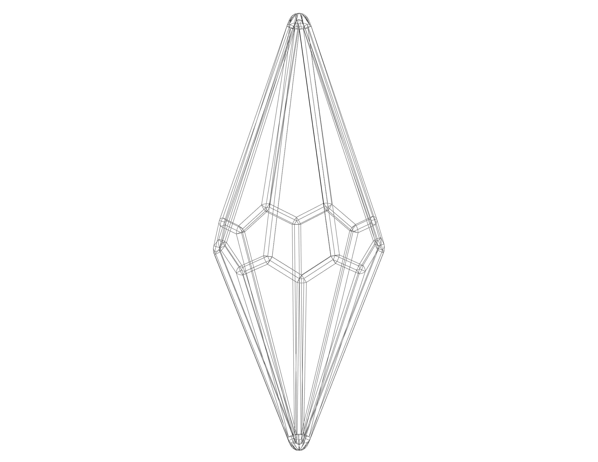

Key Points
# Source: AI Source: Provided by: [Data Path: Persons Table -> ID Column: 1, Name_En Column: Motasem Essam] -> From: [ChatGPT] on [7/25/2026]
- A nonagonal trapezohedron is a convex polyhedron.
- It has 18 congruent kite-shaped faces.
- It has 36 edges.
- It has 20 vertices.
- It has two opposite apexes.
- Each apex is shared by nine faces.
- Each of the other 18 vertices is shared by three faces.
- It has 9-fold rotational symmetry.
- It is the dual polyhedron of a nonagonal antiprism.

Conclusion
# Source: AI Source: Provided by: [Data Path: Persons Table -> ID Column: 1, Name_En Column: Motasem Essam] -> From: [ChatGPT] on [7/25/2026]
A Nonagonal Trapezohedron is a three-dimensional convex polyhedron consisting of 18 congruent kite-shaped faces arranged symmetrically around a central axis. It has 36 edges and 20 vertices, including two opposite apexes and two staggered rings of nine vertices.
Its defining characteristic is its twisted arrangement of kite-shaped faces and its ninefold rotational symmetry.

